1.2

Object Oriented Hello World

Thanh Minh

1. Evidence of the code

Program.cs

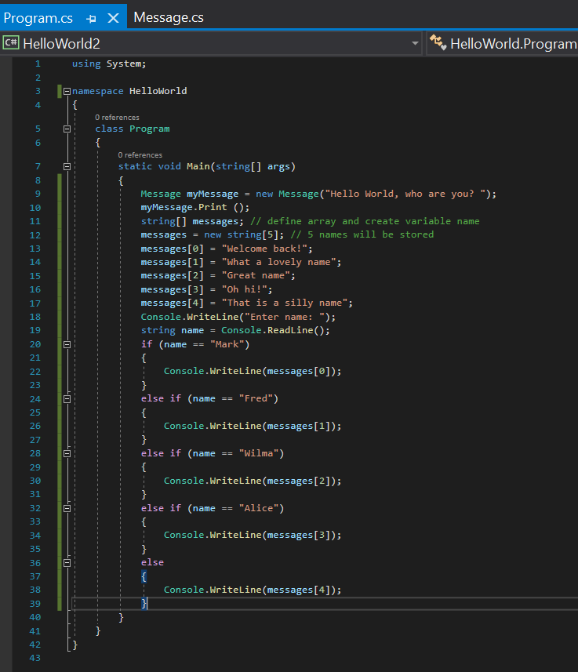

Message.cs

1. Evidence of break point within the program

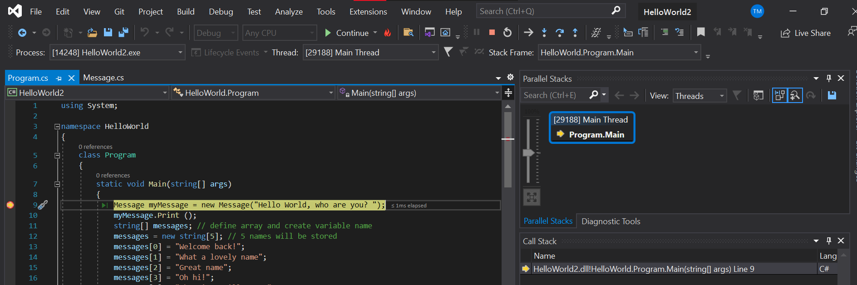

1. Output

